Static Pages

1. Landing Page

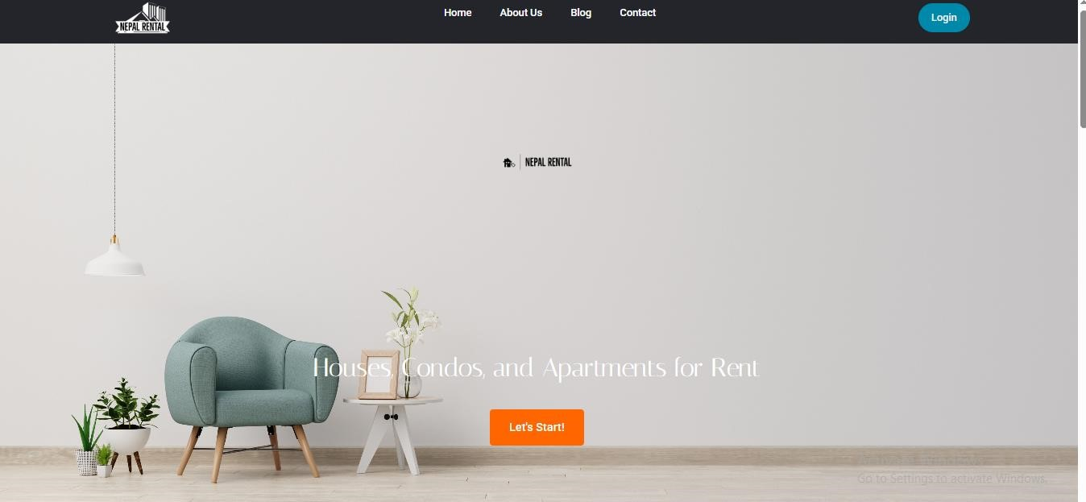

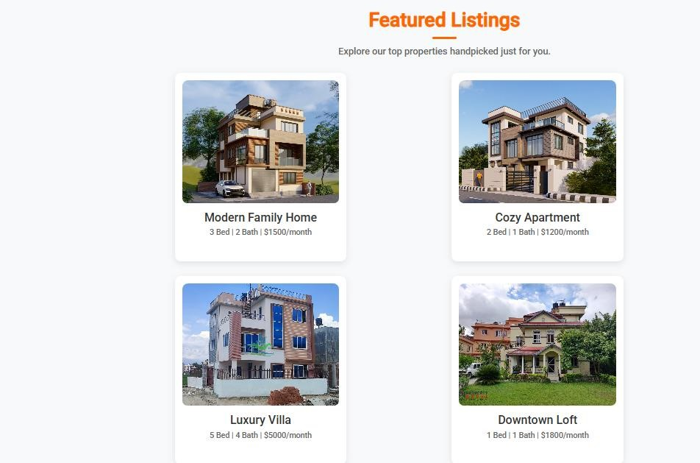

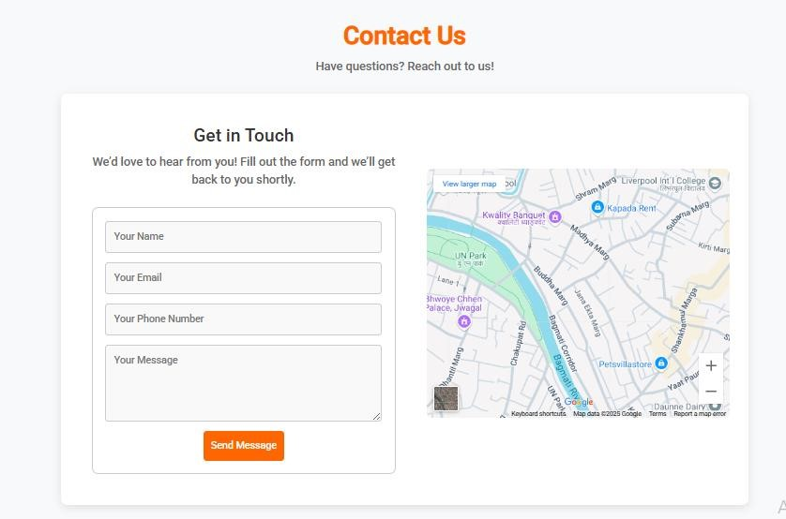

1. About-Us Page

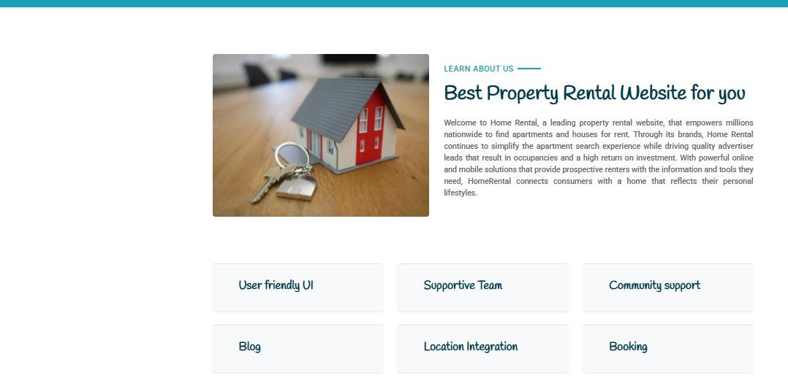

1. Blog page

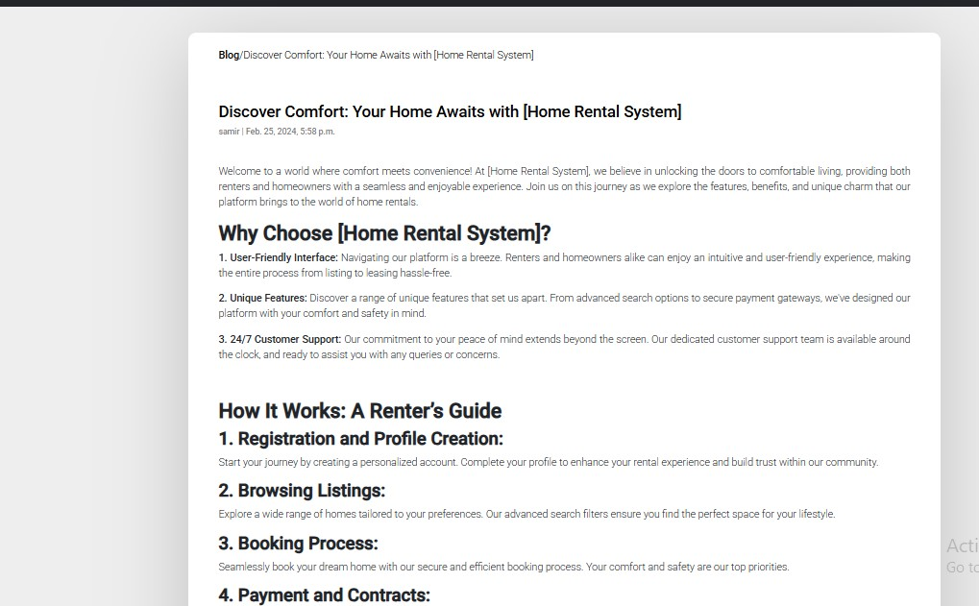

1. Contact Page

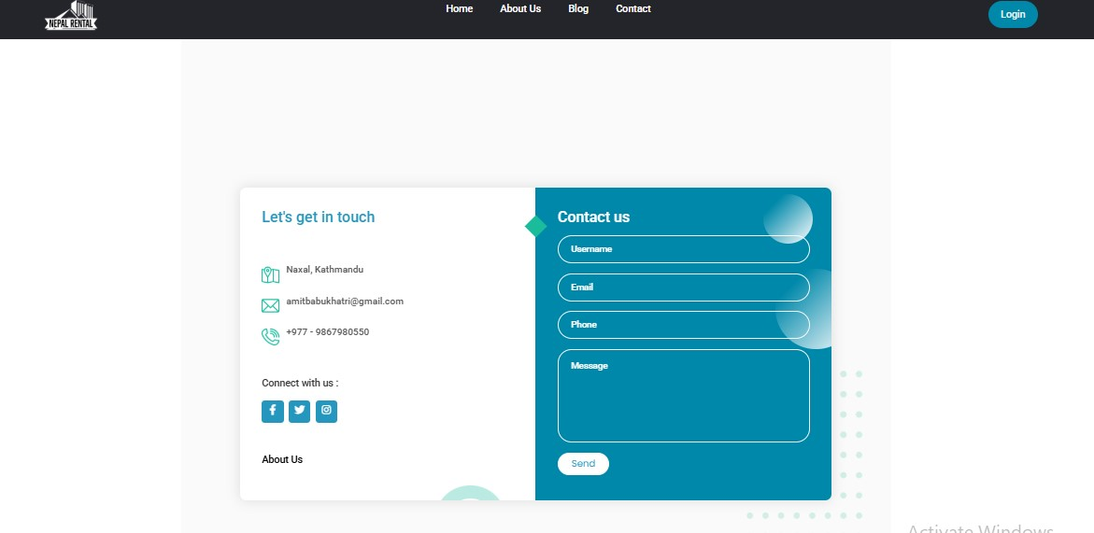

1. Contact-Us Page

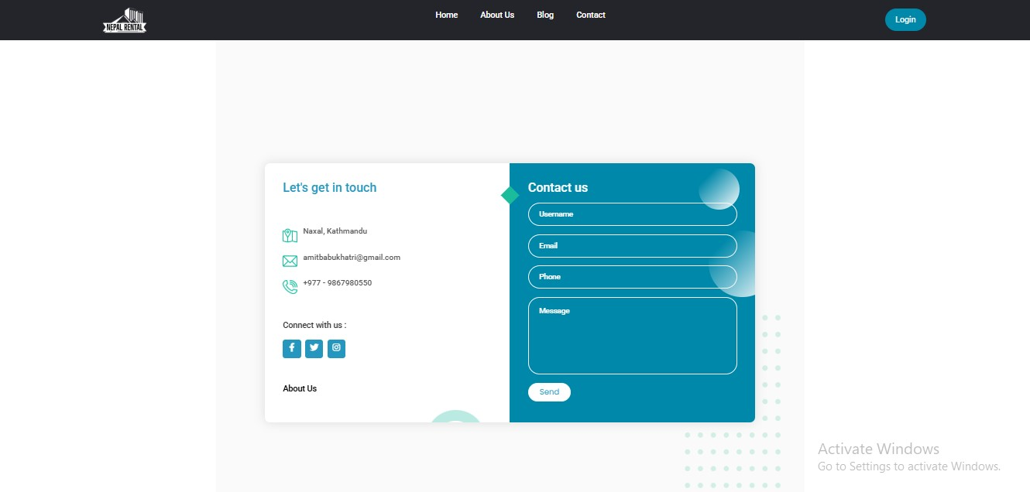

User Actions

7. User tries to register

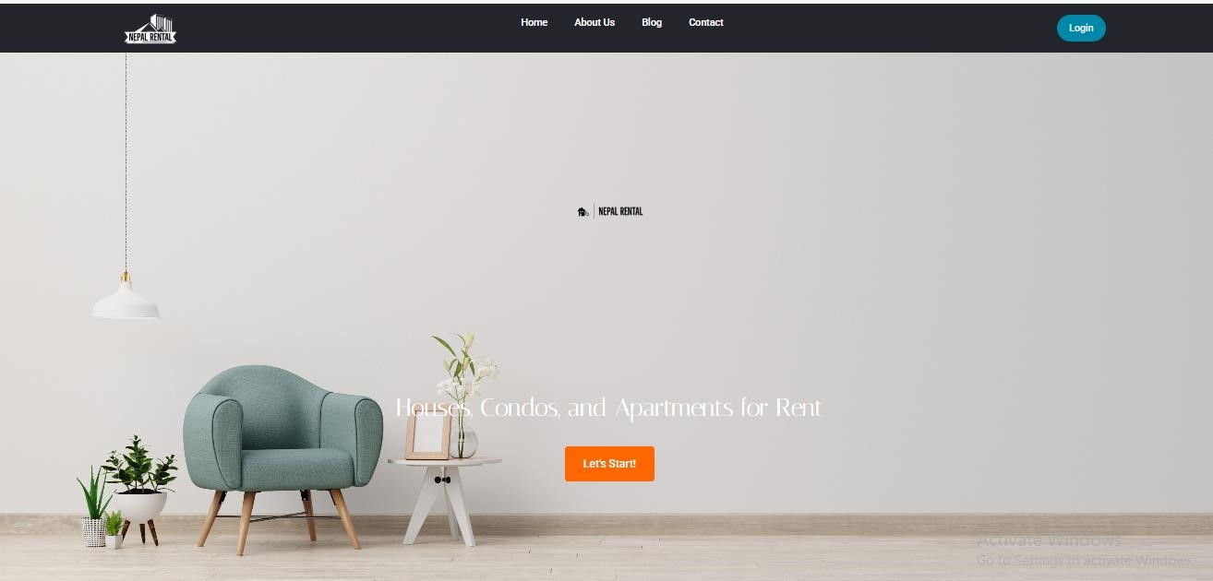

User is presented with the Signup form, where user needs to fill all the details.

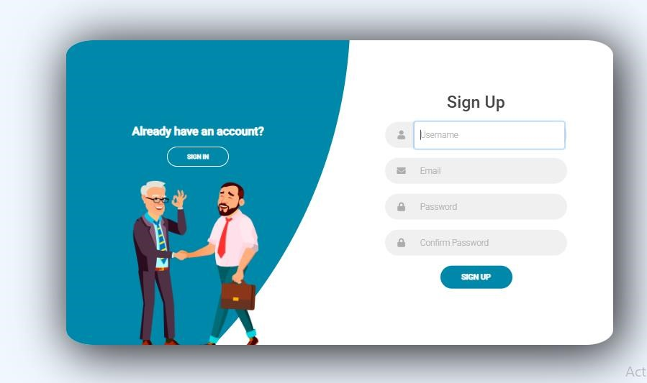

User fills the fields with their data and clicks on signup.

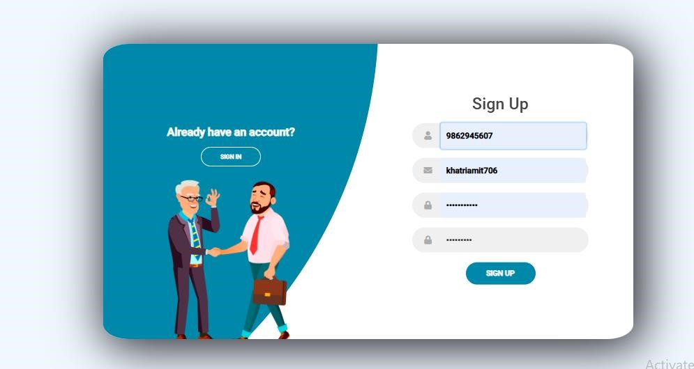

User receives success message, to activate account.

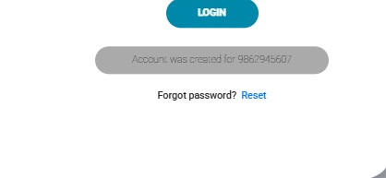

1. User tries to login

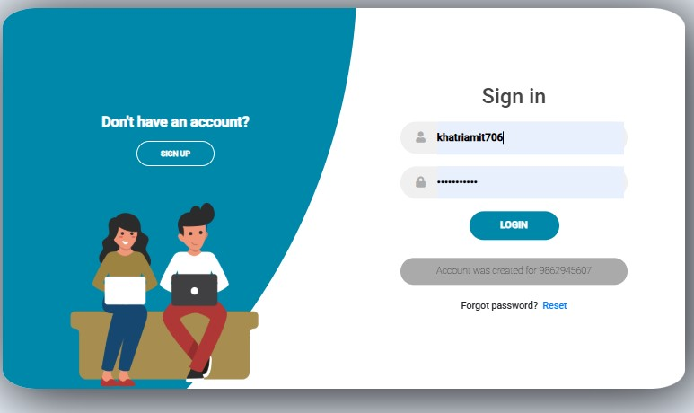

User is presented with login page, where user needs to enter their email and password, used during registration. User can also see different choices, if they want to use them.

1. User tries to reset forgotten password

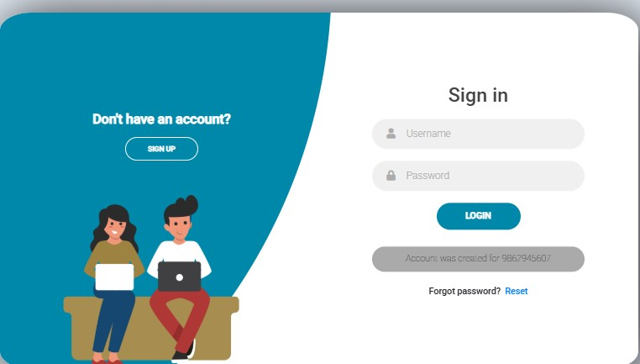

User uses the link present in the login page, to initiate password reset process.

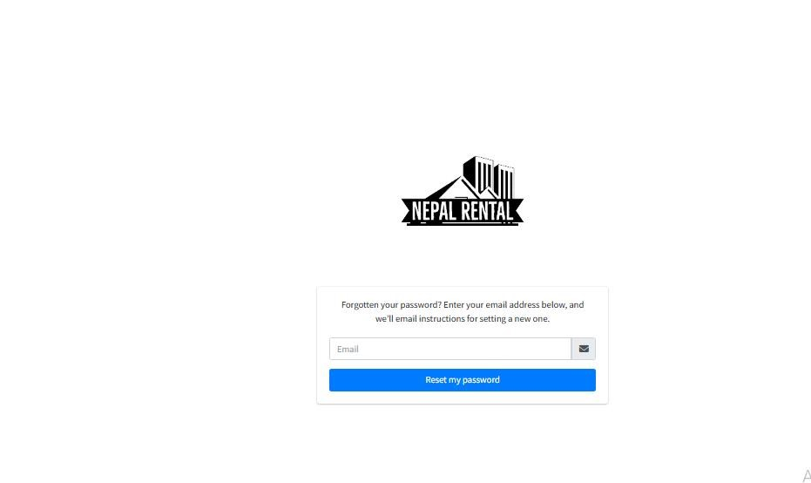

• User is taken to the page where they need to enter their registered email address and reset password will go to the mail.

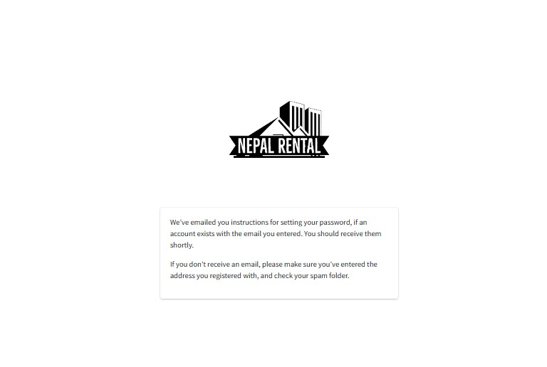

Then user can reset their password

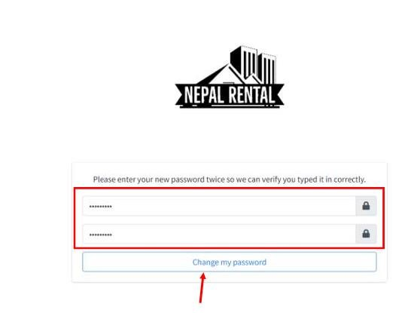

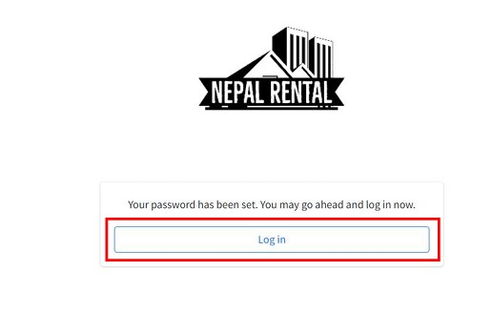

12. Dashboard

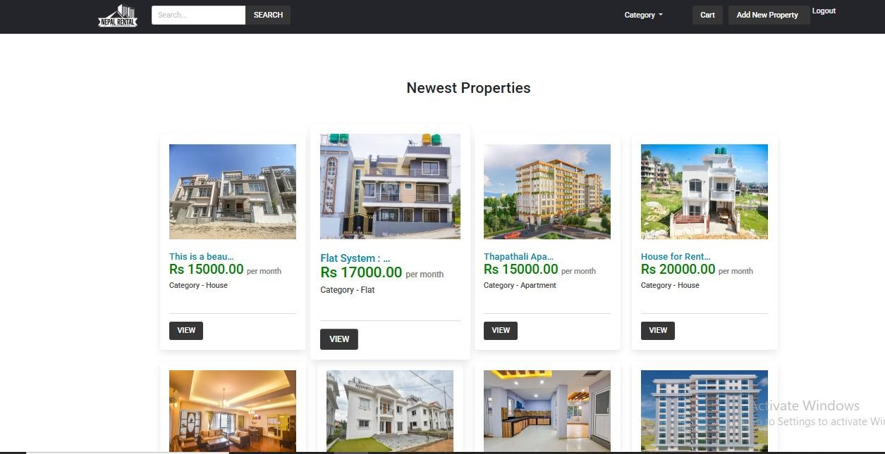

User can see different kind of icon avaibale on the dashboard where user get login.

12. Search icon

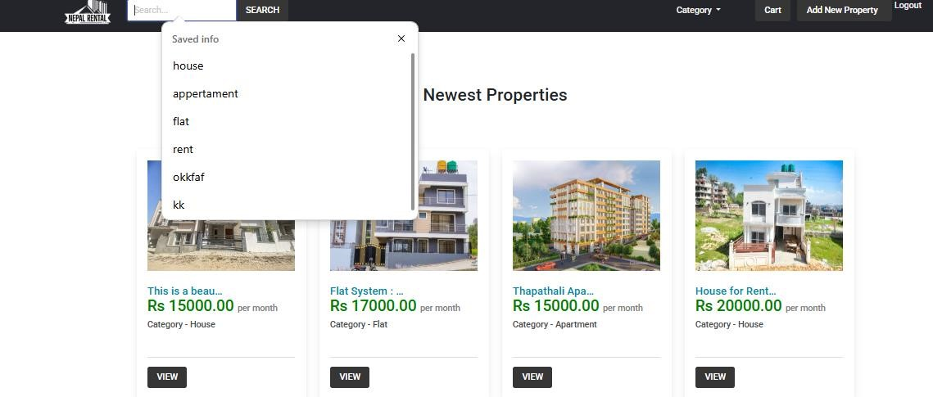 user can search according they want either house apertament or flat.

13.category section

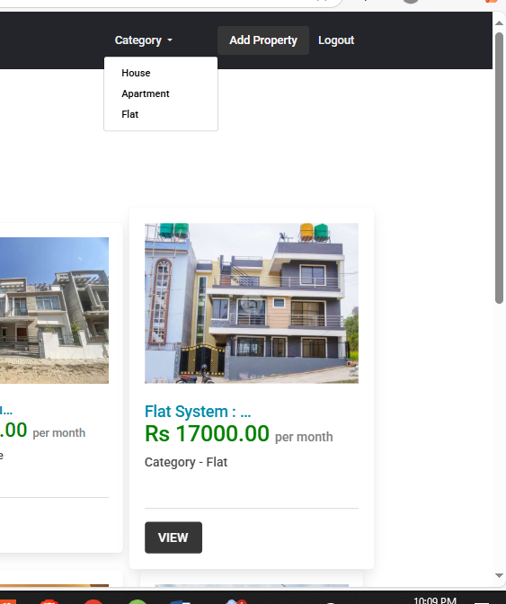

User can see category section and select which type of rent they want.

14.House section

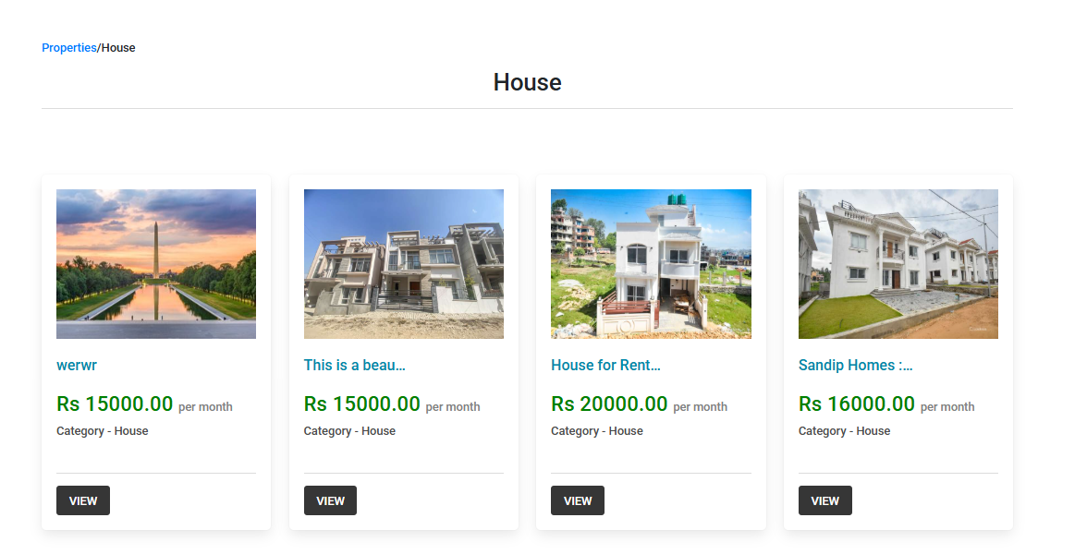

This is house section where user can see different kind of house in rent with different price.

15.Apartment

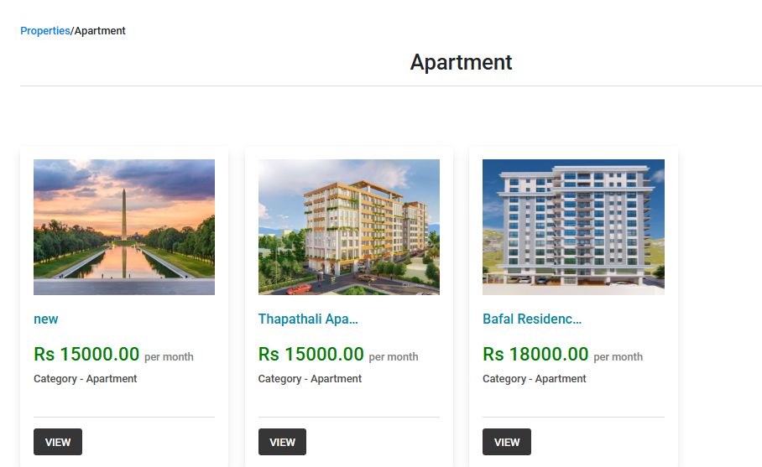

This is house section where user can see different kind of apartment with different kind or price rang.

16. Flat section  
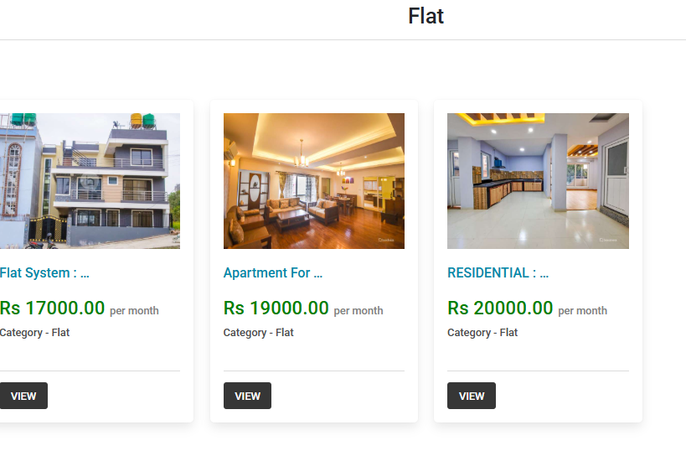

This section is flat section where user can see different kin of flat with price range.

16. View section

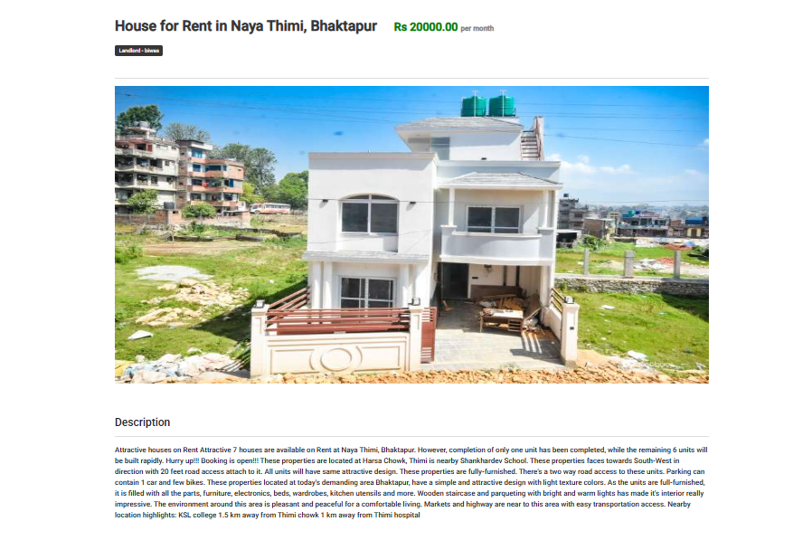

This is view section where user can view all the details of house it included main key factor like price location, number of room and facilities.

17. Add Property

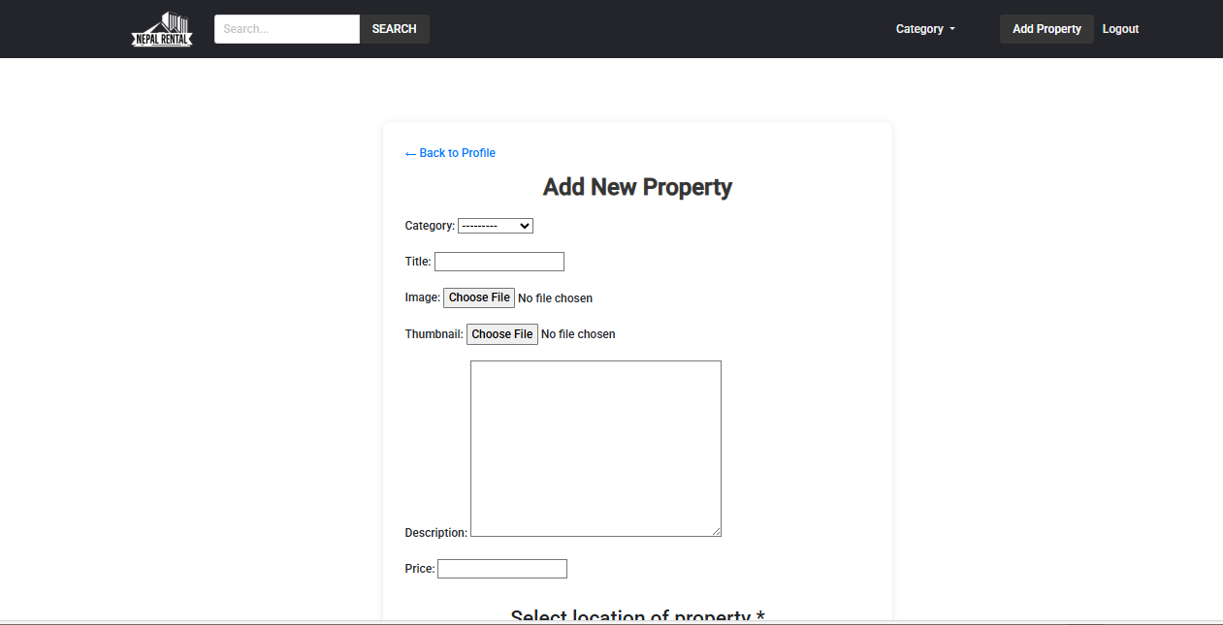

This is add property section where user can add their property if they want to sell it they can set image house description and location on it.

18. Book section  
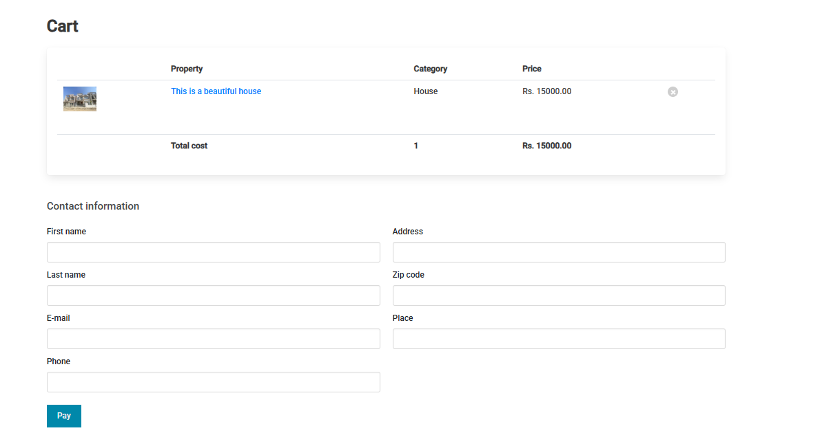

This is book now section where user should provide all the basic information before booking.

19.Apply coupon section  
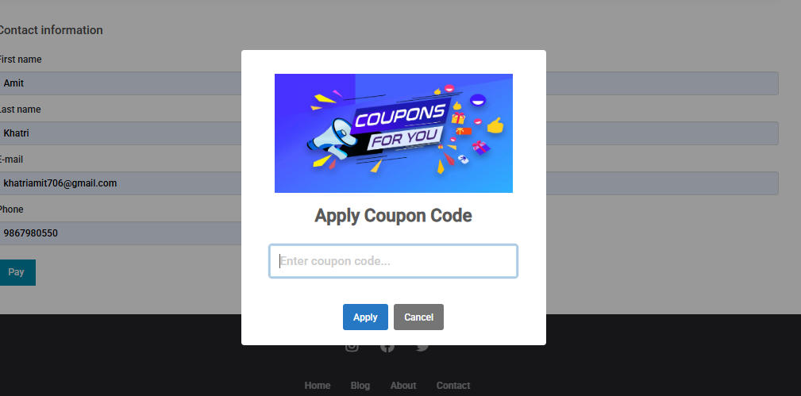

User can apply the coupon to get different kind of offer and discount that are available on the page or site.

20.Proceed paymemt  
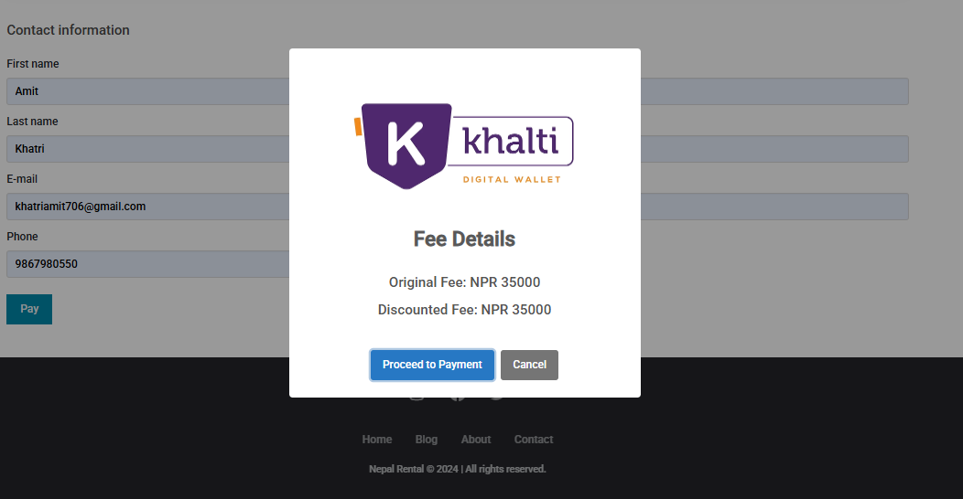

User can use khalti payment method to pay for the flat house or apartment to proceed payment.

21. khalti wallet  
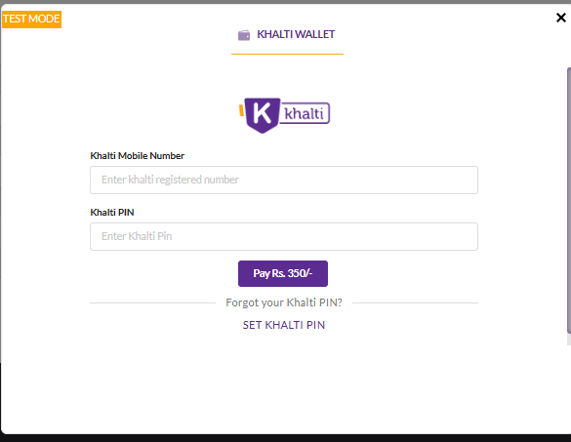

User should provide khalti number and its pin to pay for it.